**Innovation Marathon Project**

**A PROJECT REPORT ON**

**“Crop Health Detection”**





**PUNE DISTRICT EDUCATION ASSOCIATION’S**

**COLLEGE OF ENGINEERING, MANJARI, PUNE-412307**

**CERTIFICATE**

This is to certify that the Project titled

“Crop Health Detection”

Carried out under the guidance of Mr. Mario Thokchom,

submitted to the Code Unnati Innovation Marathon.

**Submitted By:**

Sanika Satyawan Totre

As the partial fulfilment of SAP training course of

“SAP training in collaboration with Edunet Foundation” during 2023-24

**Crop Health Detection**

**INDEX**

|  |  |  |
| --- | --- | --- |
| **Sr.no.** | **Title** | **Page no.** |
| 1 | Introduction | 4 |
| 2 | Overview Crop Health Detection | 5 |
| 3 | Requirement Analysis | 6 |
| 4 | User Interaction | 9 |
| 5 | Deployment and Hosting | 8 |
| 6 | Source Code | 15 |
| 7 | Challenges and Future Enhancement | 20 |
| 8 | Conclusion | 21 |
| 9 | References | 21 |

**Introduction**

The project aims to develop a Crop Health Detection System (CHDS) using deep learning, CNN, TensorFlow, and Google Cloud. Traditional methods for monitoring crop health lack efficiency, leading to significant yield losses. The CHDS addresses this by providing real-time identification of crop health issues such as diseases and nutrient deficiencies.

Utilizing CNN and TensorFlow, the system offers timely insights, enabling farmers to mitigate crop damage and maximize yields. Designed for accessibility, it integrates seamlessly into existing farming practices, empowering farmers with actionable insights without requiring extensive technical expertise.

Cost-effectiveness is prioritized, ensuring affordability for smallholder and large-scale farmers. Leveraging cloud computing minimizes infrastructure costs, making it practical for various budget constraints.

Data privacy is upheld through stringent protocols and encrypted communication channels, safeguarding farmers' sensitive information.

The CHDS represents a significant advancement in agricultural technology, revolutionizing crop health management and contributing to global food security.

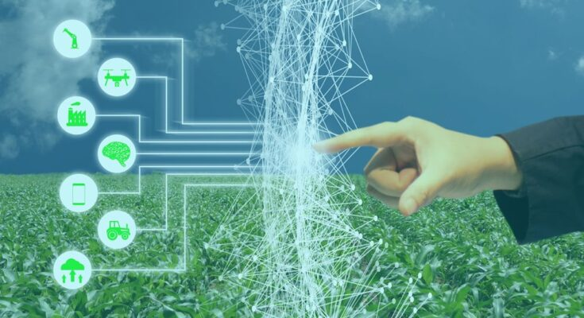

**Overview Crop Health Detection**

The Crop Health Detection System (CHDS) utilizes deep learning, CNN, TensorFlow, and Google Cloud to revolutionize crop health monitoring. It provides real-time identification of diseases, nutrient deficiencies, and pest infestations, enabling proactive intervention to maximize yields.

**Key Components:**

1. Advanced Technology: Leveraging deep learning and CNN algorithms, the CHDS analyzes crop images to detect health issues accurately and efficiently.
2. Real-time Insights: Farmers receive instant notifications about crop health issues, empowering them to implement timely interventions and minimize yield losses.
3. User-friendly Interface: The CHDS features an intuitive interface that is accessible to farmers with varying levels of technical expertise, ensuring widespread adoption and usability.
4. Cost-effective Solution: Cloud-based infrastructure minimizes the need for expensive hardware, making the CHDS affordable for farmers across different scales of operation.
5. Data Security: Stringent data privacy measures safeguard farmers' sensitive information, ensuring confidentiality and compliance with data protection regulations.
6. Scalability: The CHDS is designed to scale with the needs of farmers, accommodating changes in crop types, farm sizes, and geographic locations.
7. Contribution to Sustainability: By facilitating early detection and targeted management of crop health issues, the CHDS promotes sustainable agricultural practices and resource optimization.

In summary, the CHDS represents a transformative solution for crop health monitoring, offering farmers the tools they need to enhance productivity, optimize resource utilization, and ensure food security.

**Requirement Analysis**

Requirement analysis is a critical phase in the development of any software project, including a Crop Health Detection. It involves gathering and defining the functional and non-functional requirements to ensure that the final product meets user expectations. Below is a breakdown of requirement analysis for your music streaming service project:

**User Requirements:**

* Farmers should be able to easily capture and upload images of their crops using smartphones or other devices.
* The system should provide clear and timely notifications to farmers about detected crop health issues.
* The user interface should be intuitive and accessible, allowing farmers to view reports, manage notifications, and access support easily.
* The system should accommodate farmers with varying levels of technical expertise, offering guidance and assistance as needed.
* Offline functionality should be available to ensure accessibility in areas with limited internet connectivity.

**Database Requirements:**

* A centralized database is required to securely store crop images and related metadata.
* The database should be scalable to accommodate the increasing volume of data generated over time.
* Robust backup and recovery mechanisms should be in place to prevent data loss and ensure continuity of operations.
* Data encryption and access control measures should be implemented to protect sensitive information and comply with data privacy regulations.

**Technical Requirements:**

* Implement deep learning algorithms for accurate crop health detection from images.
* Utilize cloud computing resources for efficient image processing and analysis.
* Develop APIs or integration points for seamless integration with existing farming management systems.
* Ensure compatibility with a wide range of devices and operating systems commonly used by farmers.
* Implement automated testing and continuous integration practices to maintain code quality and reliability.

**Performance Requirements:**

* The system should process and analyze crop images efficiently, providing real-time results to farmers.
* Response times for notifications and user interactions should be minimal, even during peak usage periods.
* Scalability is crucial to handle concurrent user access and increasing data volumes without degradation in performance.
* The system should be able to handle large image files without significant processing delays or resource consumption.

**Legal and Licensing Requirements:**

* Compliance with data privacy regulations, such as GDPR or CCPA, is essential to protect farmers' personal information.
* Ensure that all software components used in the system are properly licensed and adhere to open-source or proprietary licensing terms.
* Consideration of intellectual property rights for algorithms or technologies developed as part of the project.
* Any regulatory requirements specific to agricultural technology or crop health monitoring should be taken into account to ensure legal compliance.

**User Interaction**

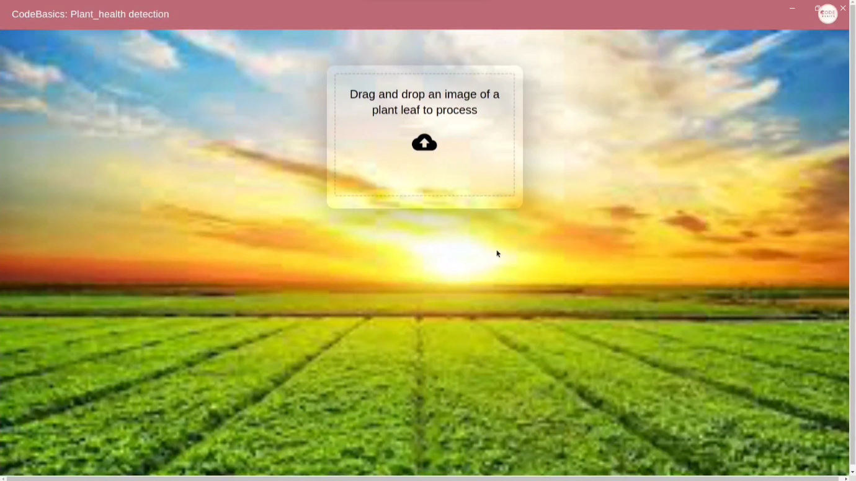

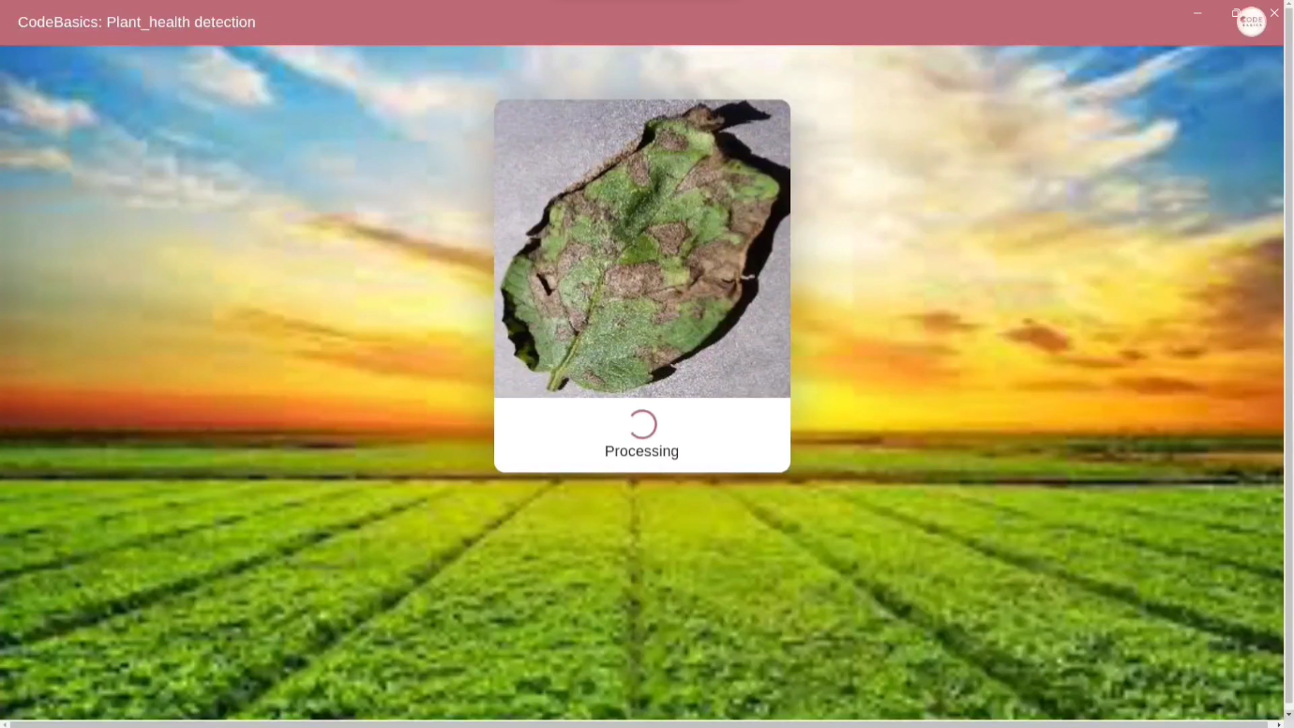

**Deployment and Hosting**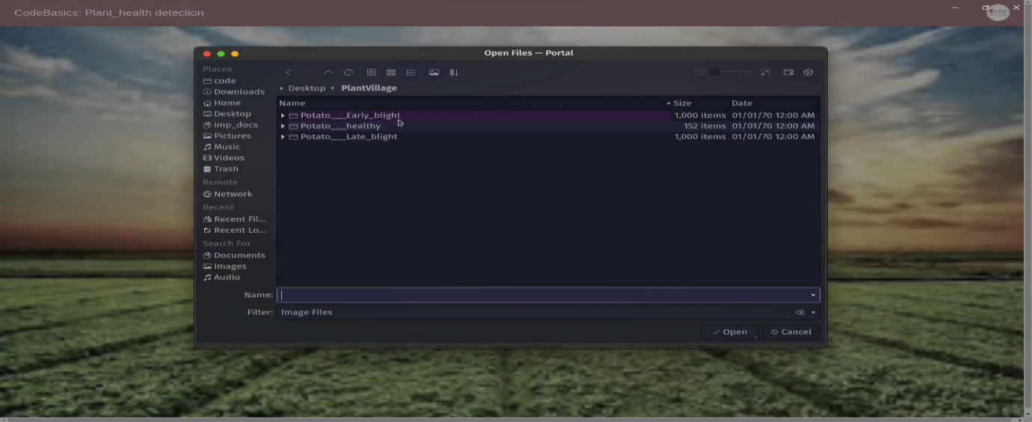

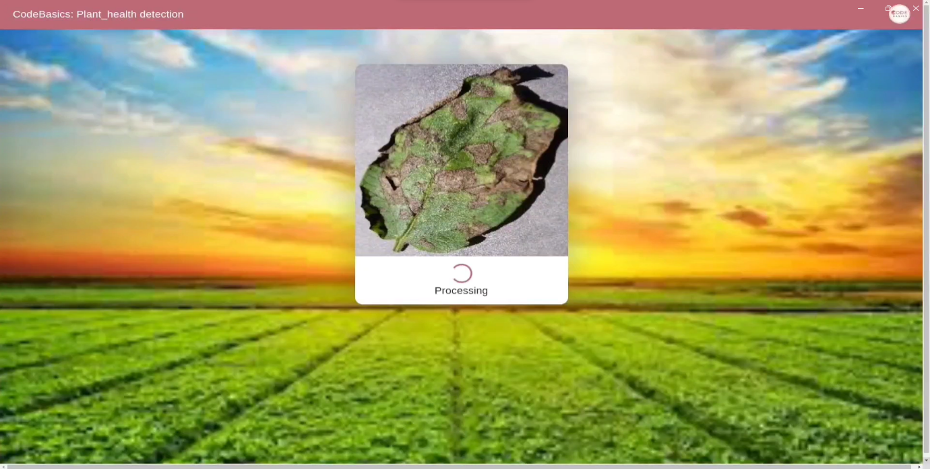

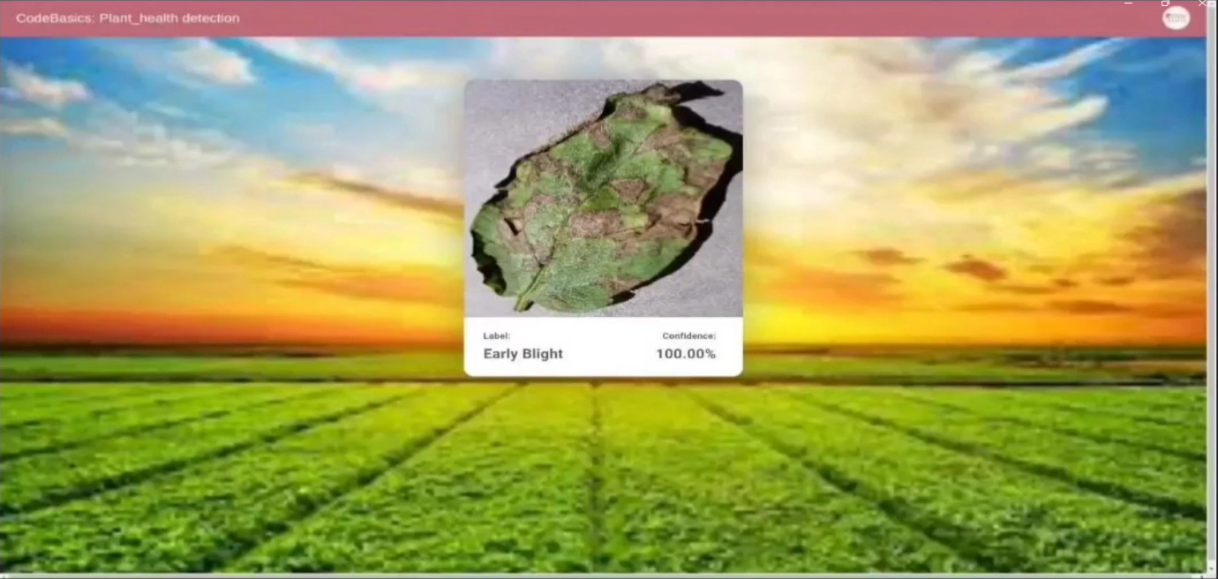

**Source Code**

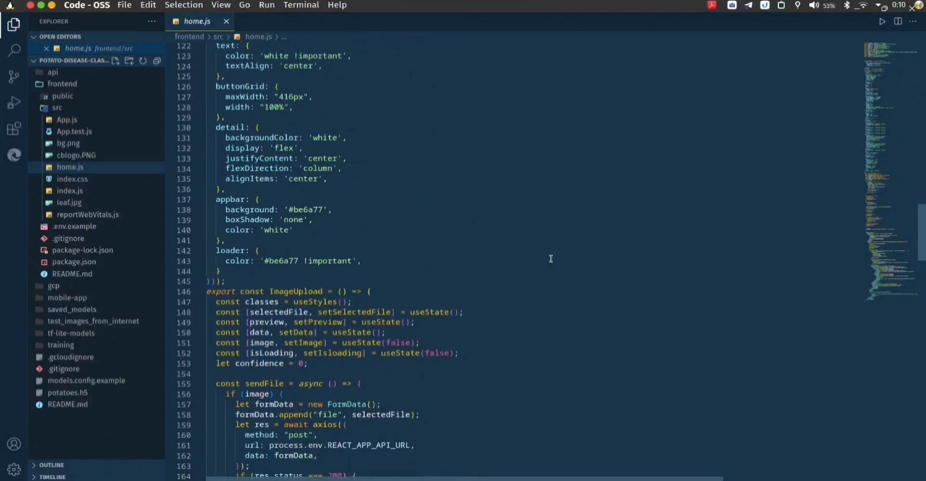

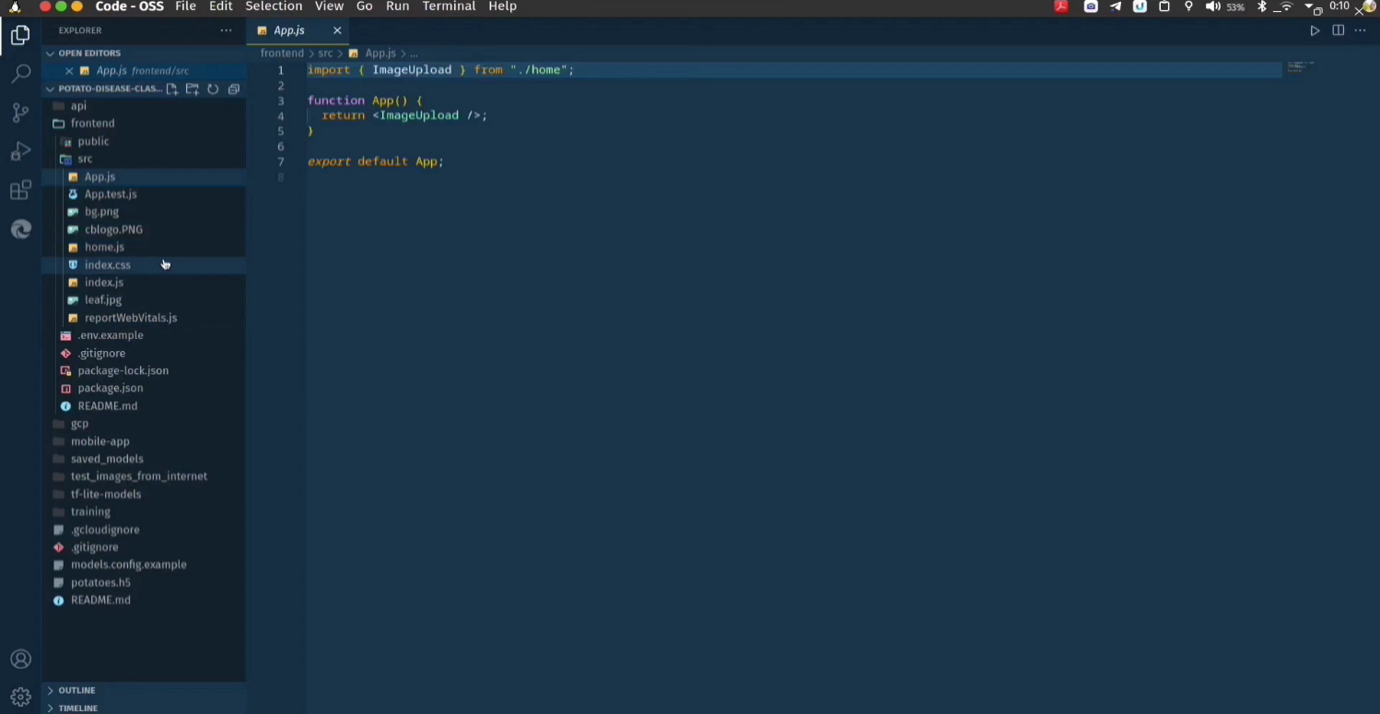

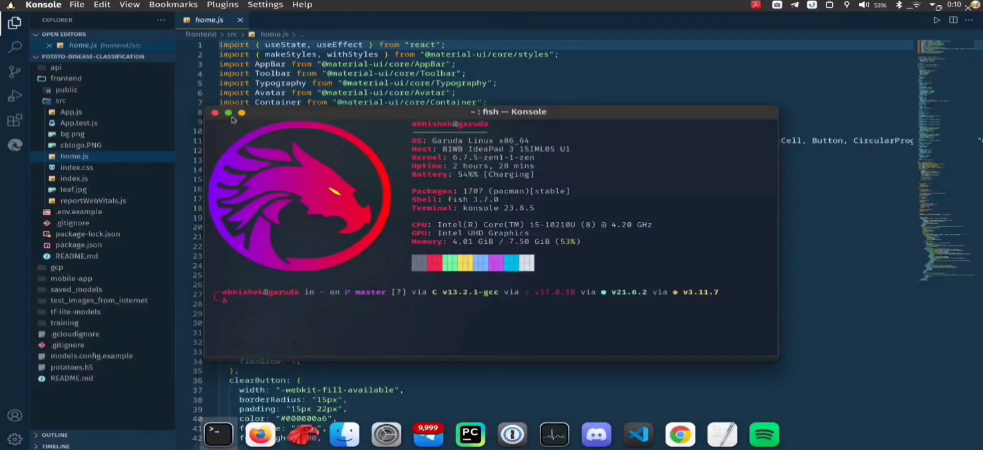

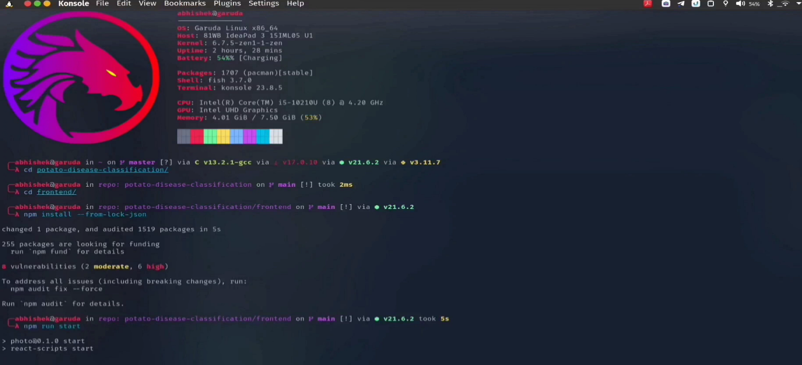

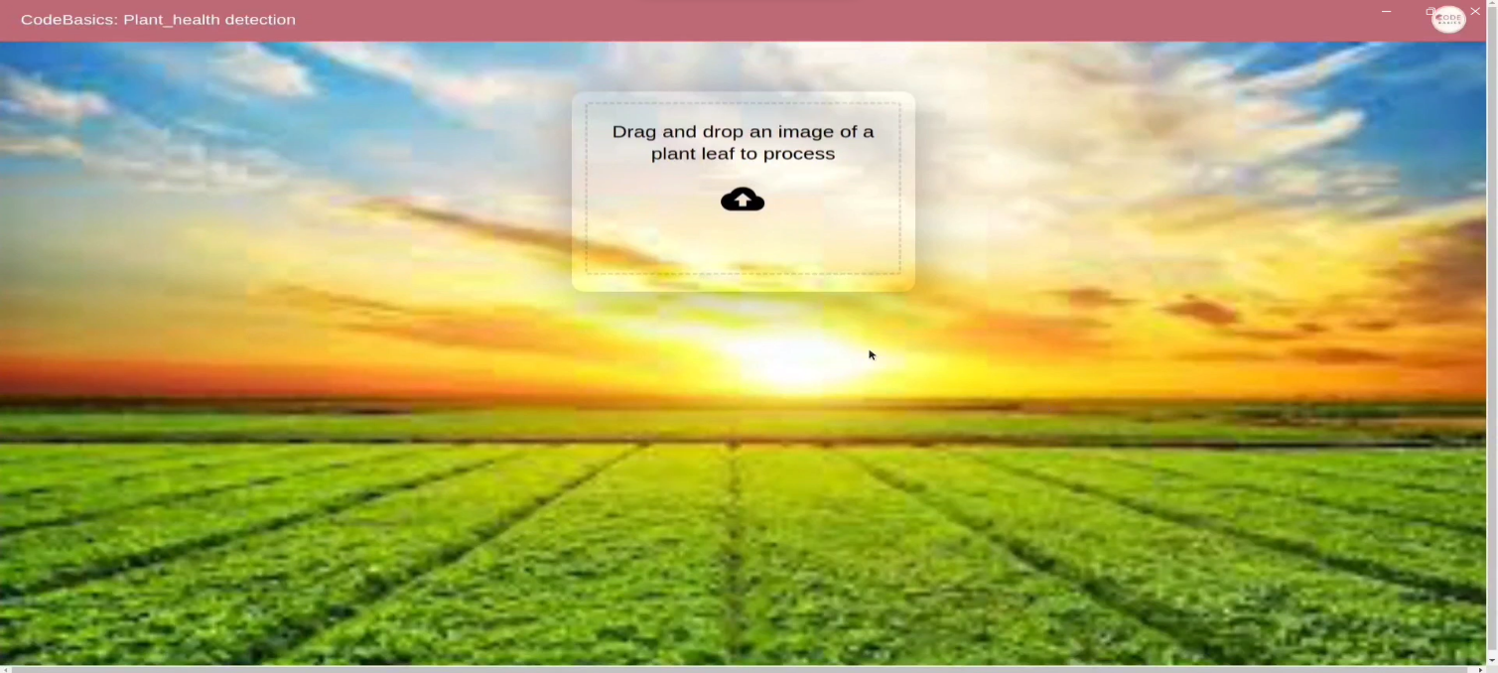

**Challenges and Future Enhancement**

**Challenges:**

* Data Quality: Ensuring the quality and diversity of the dataset used for training the deep learning models is essential for accurate crop health detection.
* Scalability: As the system grows, scaling up the infrastructure to handle increasing data volumes and user traffic while maintaining performance can be challenging.
* Interpretability: Deep learning models often lack interpretability, making it difficult for farmers to understand and trust the system's recommendations.
* User Adoption: Overcoming resistance to adopting new technologies among farmers, particularly those with limited access to resources or technological literacy.
* Data Privacy and Security: Addressing concerns regarding the privacy and security of farmers' data, particularly when using cloud-based solutions.

**Future Enhancements:**

* Advanced Analytics: Incorporating advanced analytics capabilities, such as predictive modelling and trend analysis, to provide proactive recommendations for crop management.
* Mobile Applications: Developing dedicated mobile applications with offline capabilities for capturing and uploading crop images, enhancing accessibility in remote areas.
* Integration with IoT Devices: Integrating with IoT devices such as sensors and drones to gather real-time data on environmental conditions and crop health indicators.
* Blockchain Technology: Implementing blockchain technology to enhance data security and transparency, enabling farmers to have full control over their data.
* Collaborative Platforms: Creating collaborative platforms where farmers can share insights and best practices, fostering community engagement and knowledge sharing.
* Localization: Customizing the system to address the specific needs and challenges of different agricultural regions and crop types, enhancing its relevance and effectiveness.
* Continuous Model Improvement: Implementing mechanisms for continuous model improvement through feedback loops and ongoing data collection, ensuring that the system remains accurate and up-to-date.
* AI Explainability: Researching and implementing techniques for explaining the reasoning behind the system's recommendations, improving trust and usability for farmers.

**Conclusion**

In conclusion, the Crop Health Detection System offers farmers a cutting-edge solution for timely and accurate crop health management. Overcoming challenges such as data quality and user adoption, the system stands poised to revolutionize agriculture. With ongoing enhancements and a commitment to innovation, it promises to be a cornerstone of sustainable farming practices, ensuring food security and resilience in the face of evolving challenges.

The Crop Health Detection System heralds a new era in precision agriculture, providing farmers with actionable insights to optimize yields and minimize risks. By embracing advancements in technology and addressing key challenges, it exemplifies the potential of AI-driven solutions in shaping the future of farming. With continued collaboration and refinement, it holds the promise of transforming global agriculture for the better. 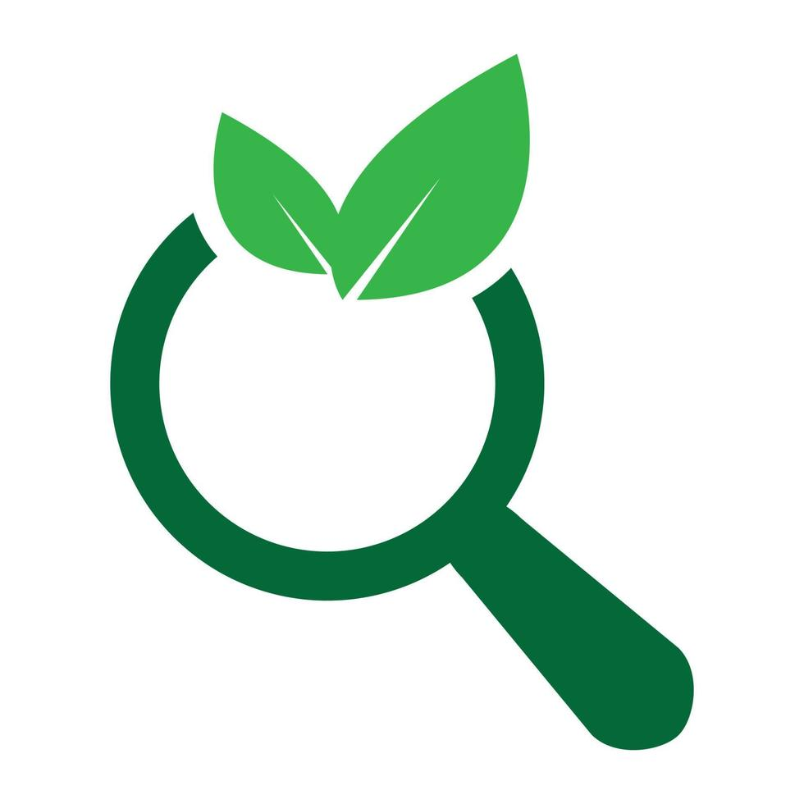

**References**

BOOKS

* "Artificial Intelligence in Agriculture: From Theory to Practice" edited by Mahendra Rai and Raul Gonzalez-Lopez

WEBSITES

* *IEEE Xplore Digital Library*
* *Plant Health Australia*
* *Agritech Tomorrow*

ARTICLES

* "Deep learning for the detection and classification of plant diseases" by Ghosal, Saptarshi, et al.